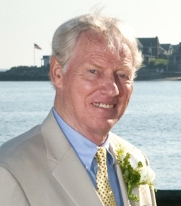
HORTON, RICHARD W, Richard Winslow Horton, age 70, of Madison, died peacefully October 17, 2013 at CT Hospice after a brave battle with cancer. He was born in Boston, MA, August 24, 1943 to the late Wendell and Jeanette Horton, and was predeceased by his brother Bruce Horton. Richard was a 1965 graduate of Dartmouth College, where he earned a BA and served as president of the Phi Delta Alpha fraternity. A scholar athlete in college, he was catcher and captain of the baseball team, played football for two consecutive Ivy League championship seasons, and was a member of Green Key Society. After graduating from Dartmouth with honors, Richard was drafted by Lou Gorman for the Baltimore Orioles in the second round of the 1965 Major League Baseball June Amateur Draft, immediately ahead of Johnny Bench, and traveled all over the country with the minor league team. After baseball, he pursued his MBA at Boston University until he was drafted during the Vietnam War. After an honorable discharge, Richard began a career in the energy industry and eventually served in a variety of leadership roles in general management and sales positions for over 30 years. He grew up and attended school in Reading, MA where he was an exemplary scholar, three-sport athlete and president of his high school class. Richard is recognized as one the finest athletes in Reading High School history and is a member of the school's Hall of Fame. He earned Massachusetts' All-Scholastic Honors recognition in football, basketball and baseball. Richard was the loving father of Rebecca Reising and her husband Thomas of Killingworth, CT, and Christopher Horton and his wife Sunho of Chatsworth, CA. He also leaves his cherished grandchildren Zachary Winslow Horton and Grayson Richard Reising. Richard is also survived by the mother of his children, Louise Horton of Raleigh, NC. Friends may call Monday, Oct. 21 from 2-5 p.m., with a celebration service to follow at 5 p.m. at the Hawley Lincoln Memorial Funeral Home, 1315 Boston Post Road, Guilford. In lieu of flowers, contributions in Richard's memory may be made to CT Hospice, 100 Double Beach Rd, Branford, CT 06405.

