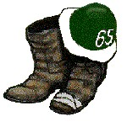

DARTMOUTH COLLEGE CLASS OF 1965

Minutes of Class conference call meeting

Tuesday, November 20, 2018

12:00 Noon

The call was hosted on Freeconferencecall.com. Michael Gonnerman called the meeting to order at 12:00 EST and referred attendees to the PowerPoint

Participating
1. Hank Amon
2. Dave Beattie
3. Carl Boe
4. Steve Fowler
5. Peter Frederick
6. Mike Gonnerman
7. Roger Hansen
8. Gary Herbst
9. Bruce Jolly
10. Brian Porzak
11. John Rogers
12. Bill Webster
13. Alan Zern

The call/meeting ended at 1:02.

