PROPOSAL FOR THE CLASS OF 1965 TO ADOPT WILLIAM (“BILL”) W. YOUNG

The Class of 1965 has two adopted members: Tom Webster, who is Bill Webster’s brother, and John Hays.

I propose that the Class adopt a third member, Bill Young. Bill, a Hanover resident, is a retired MD who has participated in our First and Second Annual Winter Trips to/from the 1965 Cabin and the College’s Winter Carnival Statue program. He brings a “local” viewpoint to our discussions about town/gown issues. He is a great conversationalist, an expert in sexual health issues, and a personal friend whom I have known since 2012.

COMMENTS FROM OUR CLASSMATES

Bob Murphy -- Sure I know Bill Young, active in town recreational affairs for many years and the guiding force behind Hanover Winter Carnival. I'd be happy to have him as an honorary class member.

Hank Amon -- I heartily endorse adopting Bill as a member of the Class of 1965. I’ve had the pleasure of getting to know Bill during the two Class winter trips to the ’65 cabin and climbs on Mt. Moosilauke. Bill has an engaging personality, is extremely knowledgeable on many subjects and is interested not only in your world but also the world around him.”

Peter Frederick -- Mike and Fellow '65's. I strongly endorse the proposal to invite Dr. Bill Young to become an adopted member of our class. I worked with Bill on the effort to revive the Winter Carnival Center of Campus snow sculpture tradition. Bill served as the subject matter expert in two area, building snow sculptures and dealing with the Town / Gown bureaucracy. He did everything you would want your classmate to do to support students and Dartmouth. Lest the Old Traditions Fail.

Dave Beattie -- I have known Bill Young from our two class winter trips to the ’65 Cabin at Moosilauke as well as some occasional e-mail exchanges in the interim since our first winter trip in February 2017. Bill is certainly an enthusiastic, outgoing supporter of Dartmouth, Class of 1965, Moosilauke, and the larger out of doors. He is keenly perceptive of larger problems facing the world and its people, and he is a thoughtful, logical thinker in discussing actions and solutions. To borrow some words from the Dartmouth Alma Mater, Bill Young has the still North in his heart, the hill winds in his veins, and the granite of New Hampshire in his muscles and his brains. I strongly support the Class of ’65 adopting Bill Young

Steve Fowler -- I support this idea. Bill is not only a very thoughtful, companionable, and energetic guy, he is an indispensable citizen in Hanover, and wonderfully connected to aid or advise the Class on projects or activities here.

John Rogers -- Bill Young? Sure. Nice letter of recommendation.

Rich Beams -- Indeed I heartily support your proposal to have our Class adopt Bill Young, who it was a great pleasure get to know on our recent jaunt at the 1965 Cabin and climbing Moosilauke. In fact, since I can’t claim by any means to know every one of our classmates, I thought for half the trip that he was in fact a ’65 - especially being such a nice guy, just like the rest of us! I must add it was great fun to not only find someone else who had climbed the Grand Teton - not just once but three times, and i greatly enjoyed talking with him about a number of topics - even opera, not always an exciting topic of conversation for some. Anyway, I think your proposal to have such a great guy be adopted by our class is great. Again, I heartily support it.

Don Bradley -- I support.

George Wittreich -- Bill Young seems like a great guy and I will be happy to have him as a class member.

Roger Hansen -- I concur. Sounds like a good fit

BIO AND PHOTOGRAPH

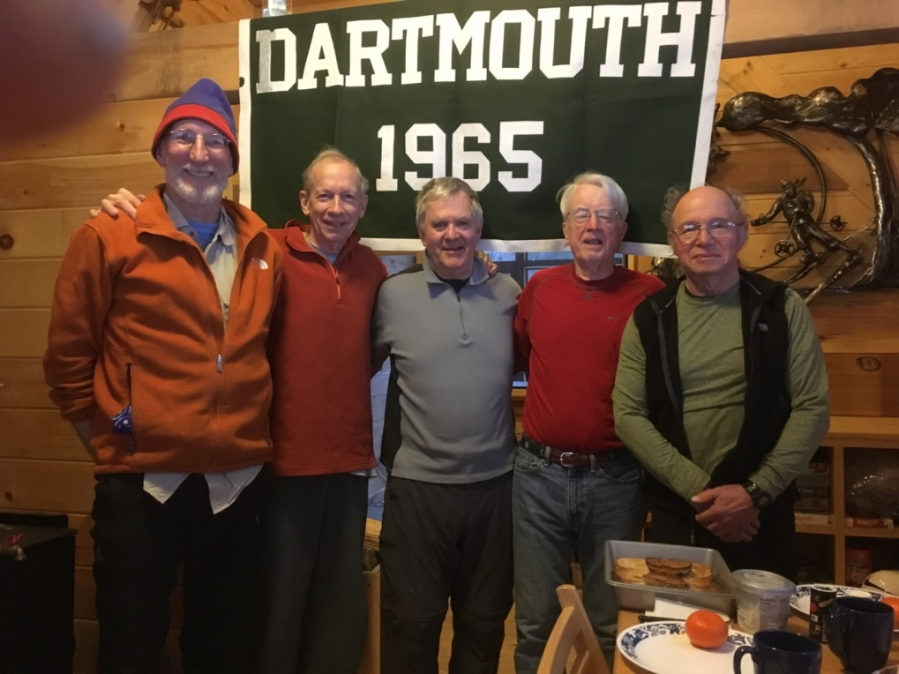

2/14/18 – at the Class of 1965 Cabin – l to r – Bill Young, Hank Amon, Rich Beams, MG, Dave Beattie

Background
- BA Miami University, 1966
- MD University of Pittsburgh, 1970
- Practiced for 30 years at Dartmouth Hitchcock Medical Center
- Emeritus Associate Professor of Obstetrics and Gynecology, Geisel School of Medicine
- Delivered “about 2,000” children
- Outdoorsman
  - has hiked Mt. Moosilauke and Mt. Washington many times
  - hiked much of the Appalachian Trail, including from Lou’s to Mt. Katahdin. Just left to hike 300 miles, starting from Springer Mountain in Georgia (start of the AT)
- Organized a number of med school social events at the Ravine Lodge
- Traveled to Kosovo and Kenya to help develop local health care systems and to Nicaragua to accompany Dartmouth medical students sent on Tucker Foundation grants
- Runner – Mt. Washington Road Race, NYC Marathon, Marine Corps Marathon
- Expert at building snow and ice statues
  - Consulted with Martha Beattie, Pete Frederick, Sherry Oberg (‘D’ trustee) and the student Winter Carnival Committee on the 2018 Winter Carnival statue
  - Worked with me on the 2017 Winter Carnival statue
  - Resurrected Hanover’s Winter Carnival pond party on Occom Pond about 25 years ago. He lives on Rope Ferry Road, and his property abuts Occom Pond.
- Member – Town of Hanover bike/pedestrian committee
- Member – Occom Pond Neighborhood Association
- Member – Pine Park Association (forested land next to golf course)

