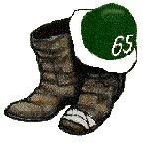

DARTMOUTH CLASS OF 1965
2022 WINTER TRIP TO THE 1965 CABIN
Monday, February 21 to Wednesday, February 23

10/22/2021. Dave Beattie and Mike Gonnerman met with Paul (“Koz”) Teplitz, Director of the Outdoor Programs Office, who gave us the green light to make the trip in 2022.

2/11/22 Mike picked up the keys to the cabin from Margaret Nichols at the DOC.

2/14/22 Dave, Bruce Atwood and Mike made a preliminary trip to the cabin to be sure everything was in order. Bruce, retired to Hanover, had joined us at Moosilauke over Homecoming and has hiked Mt. M several times. The outside temperature was 24. We were unable to unlock the doors (tumblers were frozen), and Margaret told us we needed to heat up the key/lock.

2/17/22 Bill Young ‘65A (MD, Hanover, retired OB/Gyn), and Mike made a second preliminary trip to the cabin, and were able to unlock and open the porch door. Cabin looked in good order.

Monday, 2/21/22. Dave, Bill, Bruce, Jennifer Hardy ‘65A (DCF, Managing Director) and Mike drove to the access road. We were able to drive past the 2nd gate to the point where the access road dips down toward the cabin. We unloaded the sleds and pulled them to the cabin. We were able to open the lock on the porch door, but the door was frozen in place. So, we used a hair dryer (there are electrical outlets on the porch) to melt the ice and open the door.

Snow was between 1 and 3 feet deep. Lots of postholes. Temperature inside and outside the cabin was about 24. Bruce immediately got each of the stoves fired up, and by the evening the cabin was a very comfortable 60. Got up to 70 the next morning.
\
That afternoon Dave, Bruce and Jennifer went out for a short ski trip/snowshoe hike.

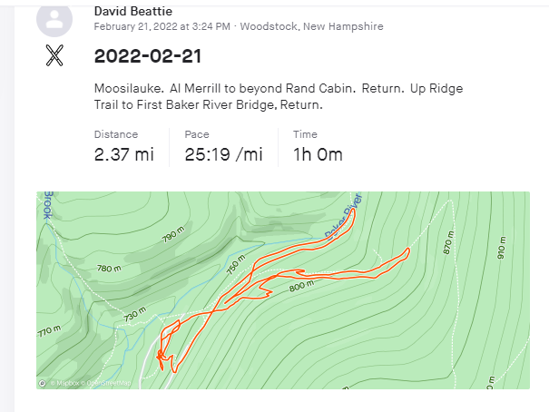

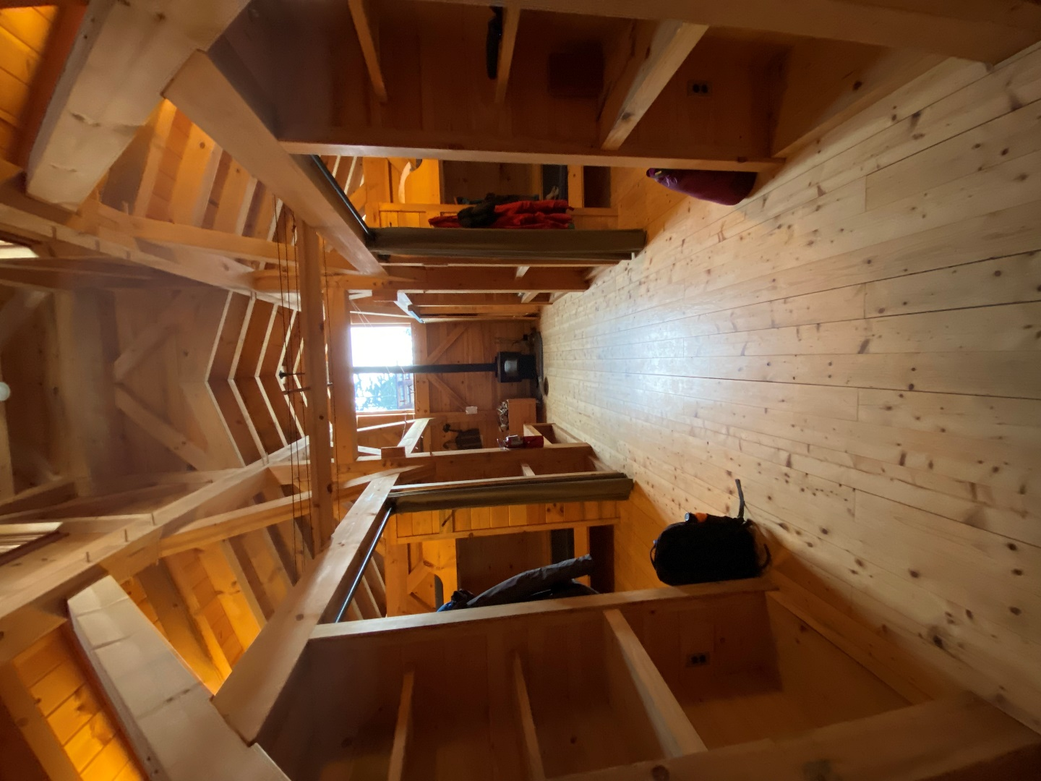

View from the back door. The building in the center is the privy below our cabin.

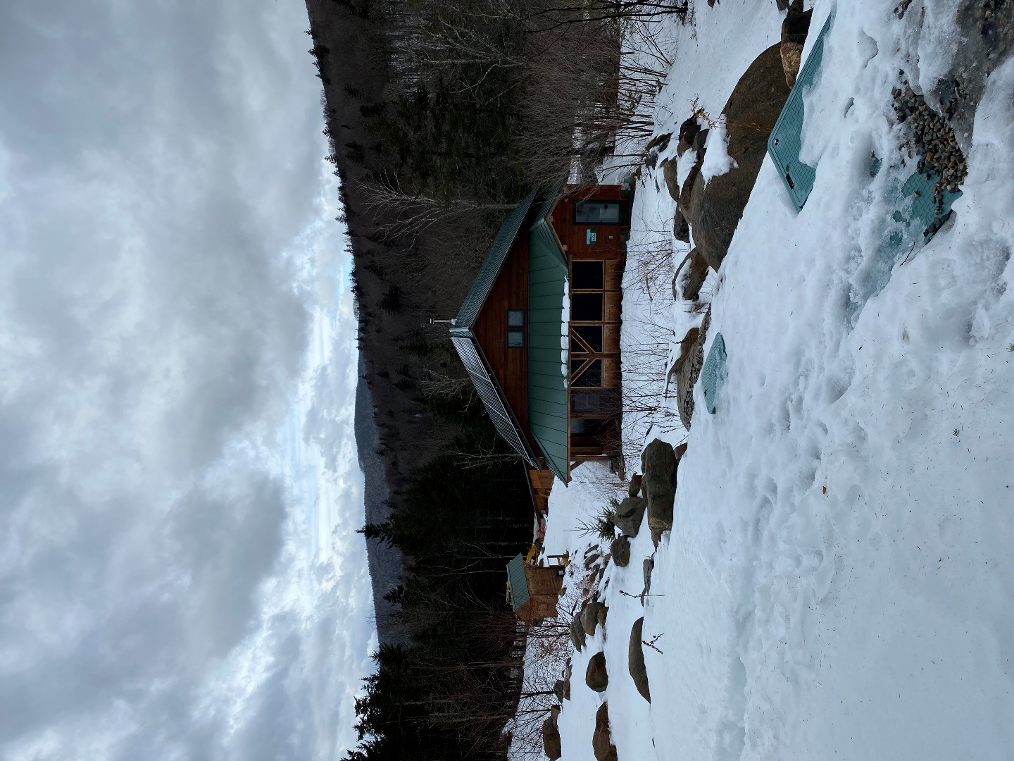

Tuesday, 2/22/22. Dave, Bruce and Jennifer hiked up Mt. M using micro-spikes. Very cold and windy at the summit.

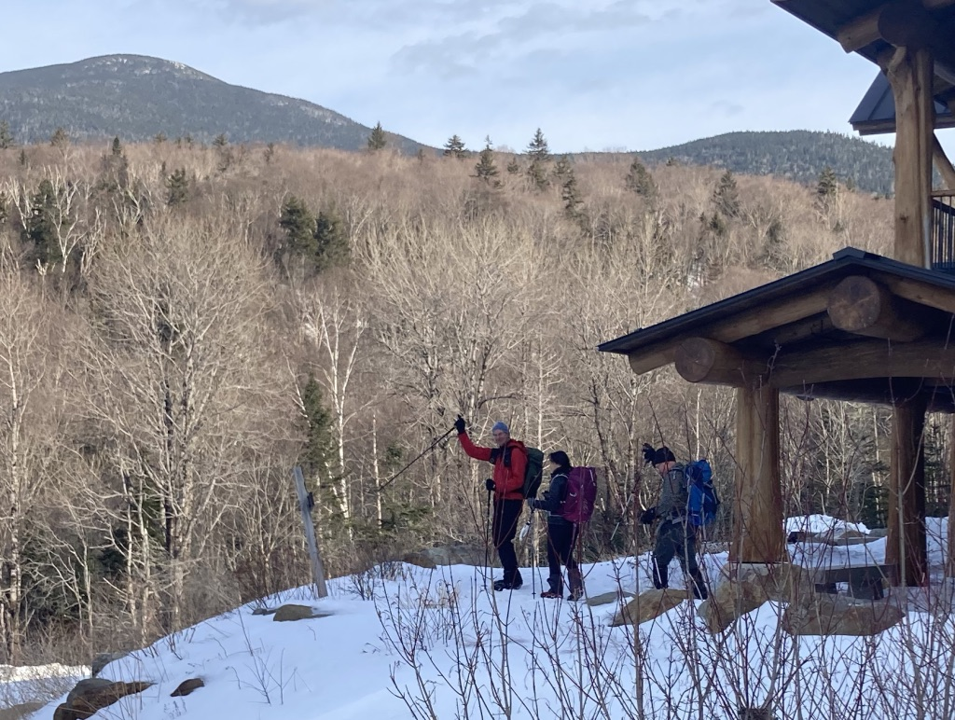

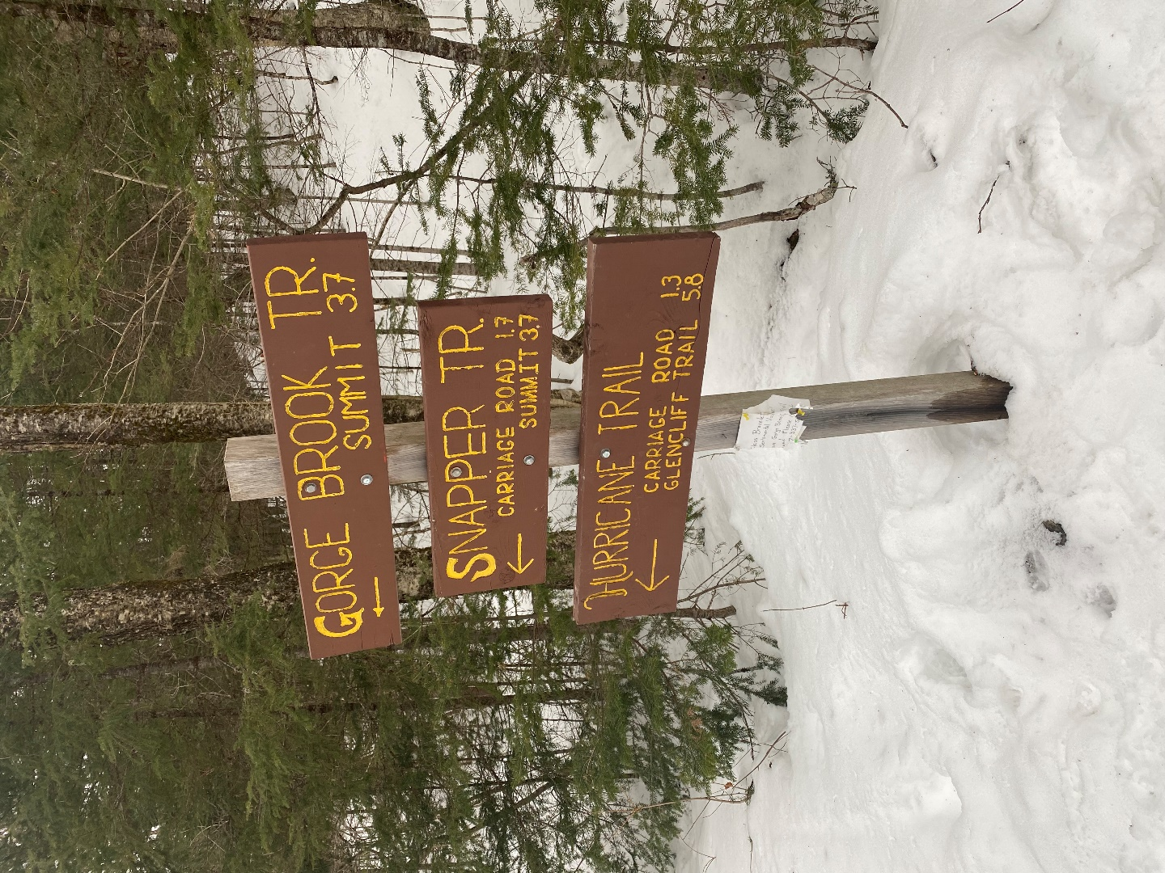

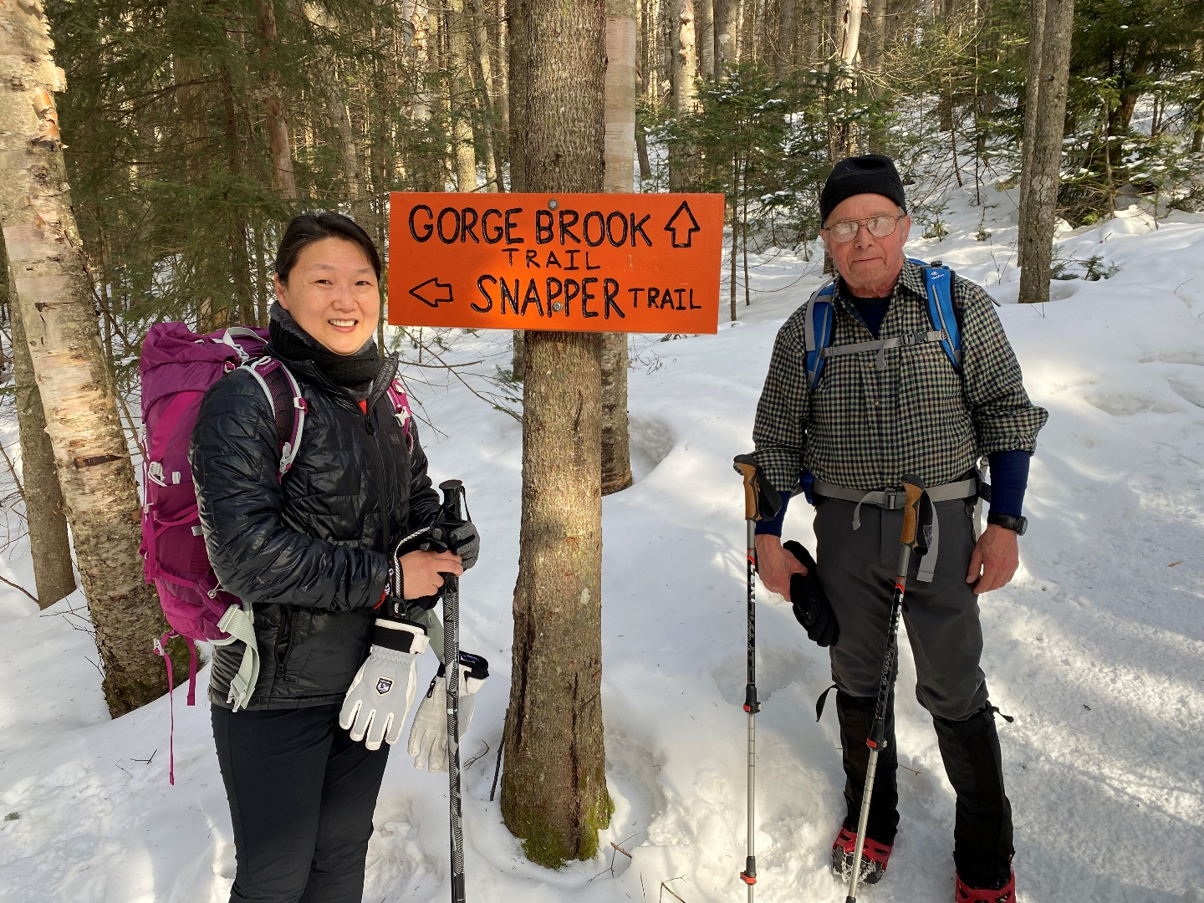
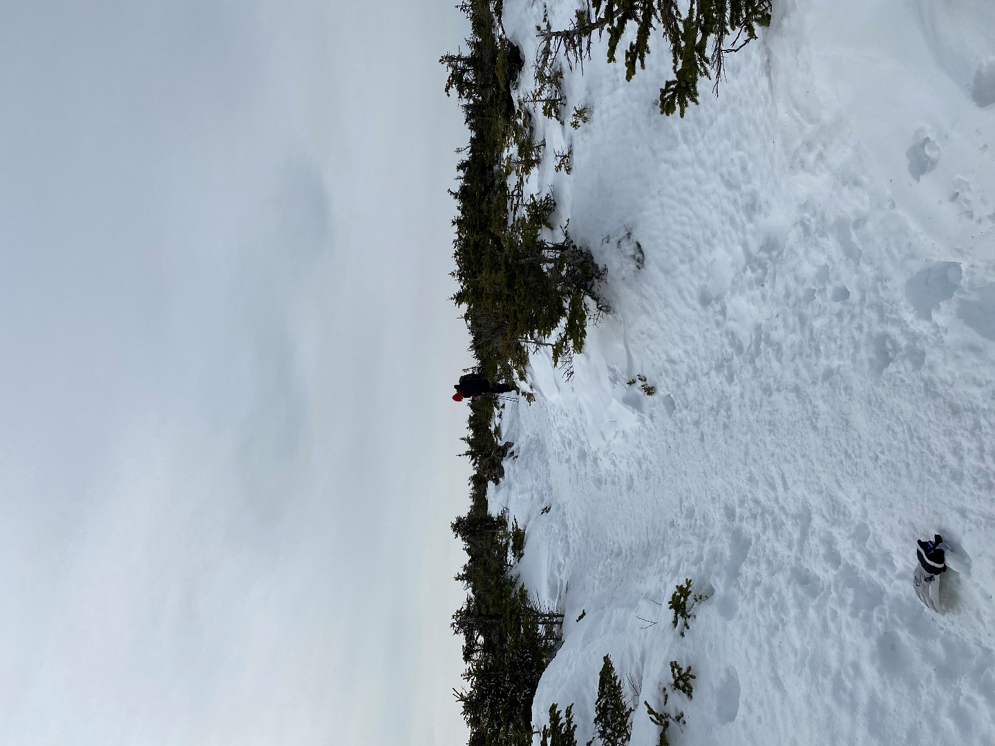

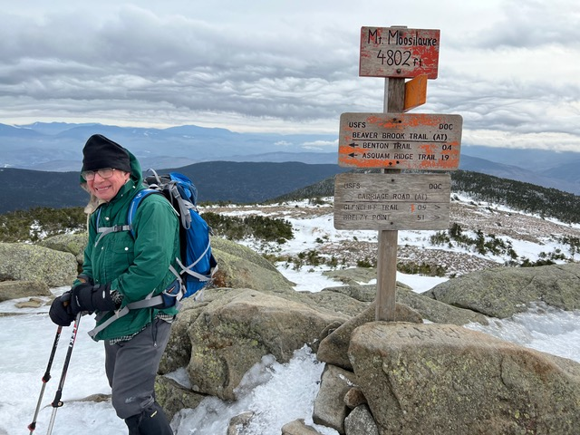

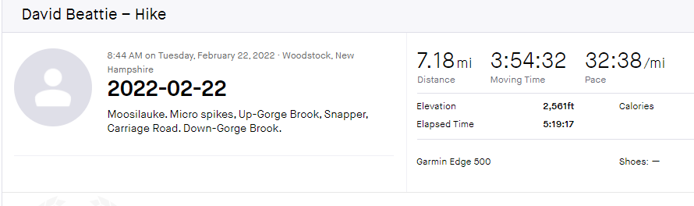

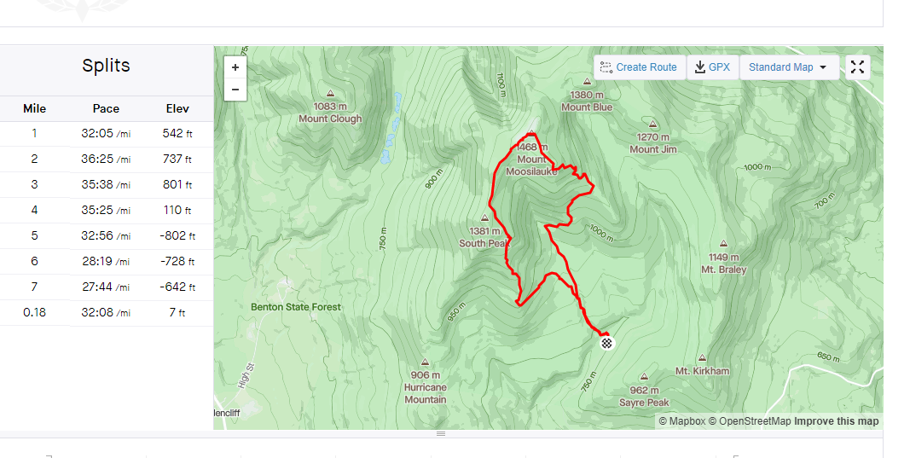

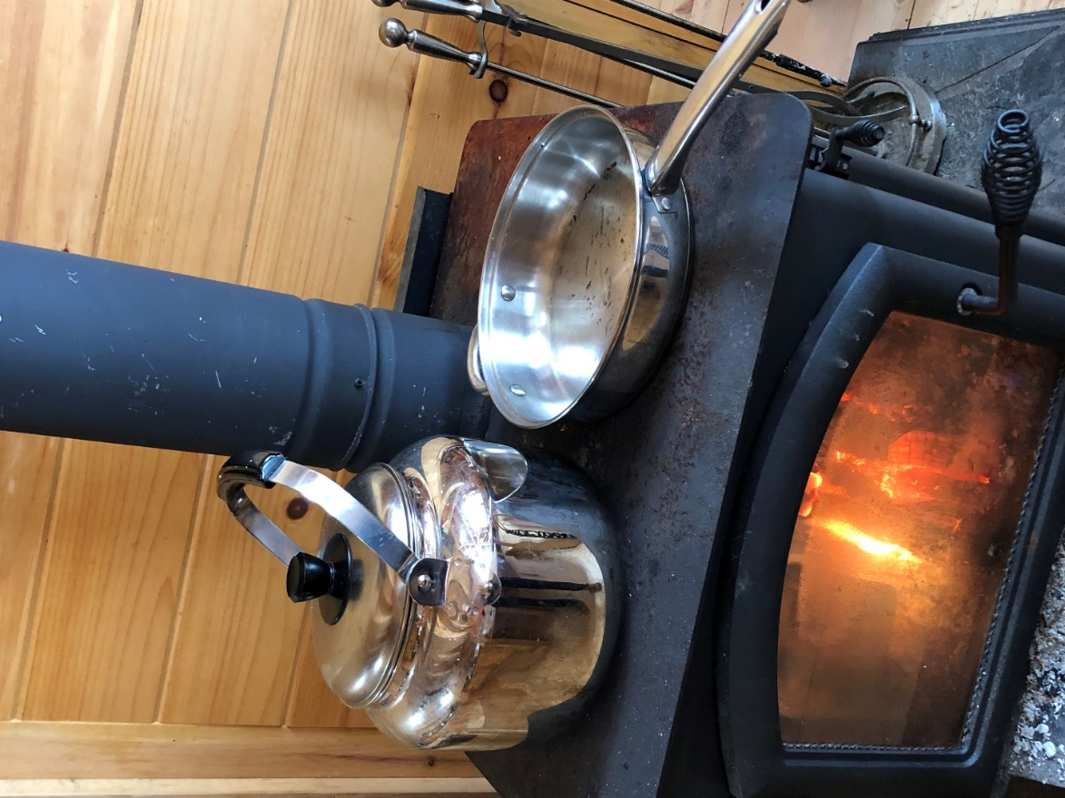

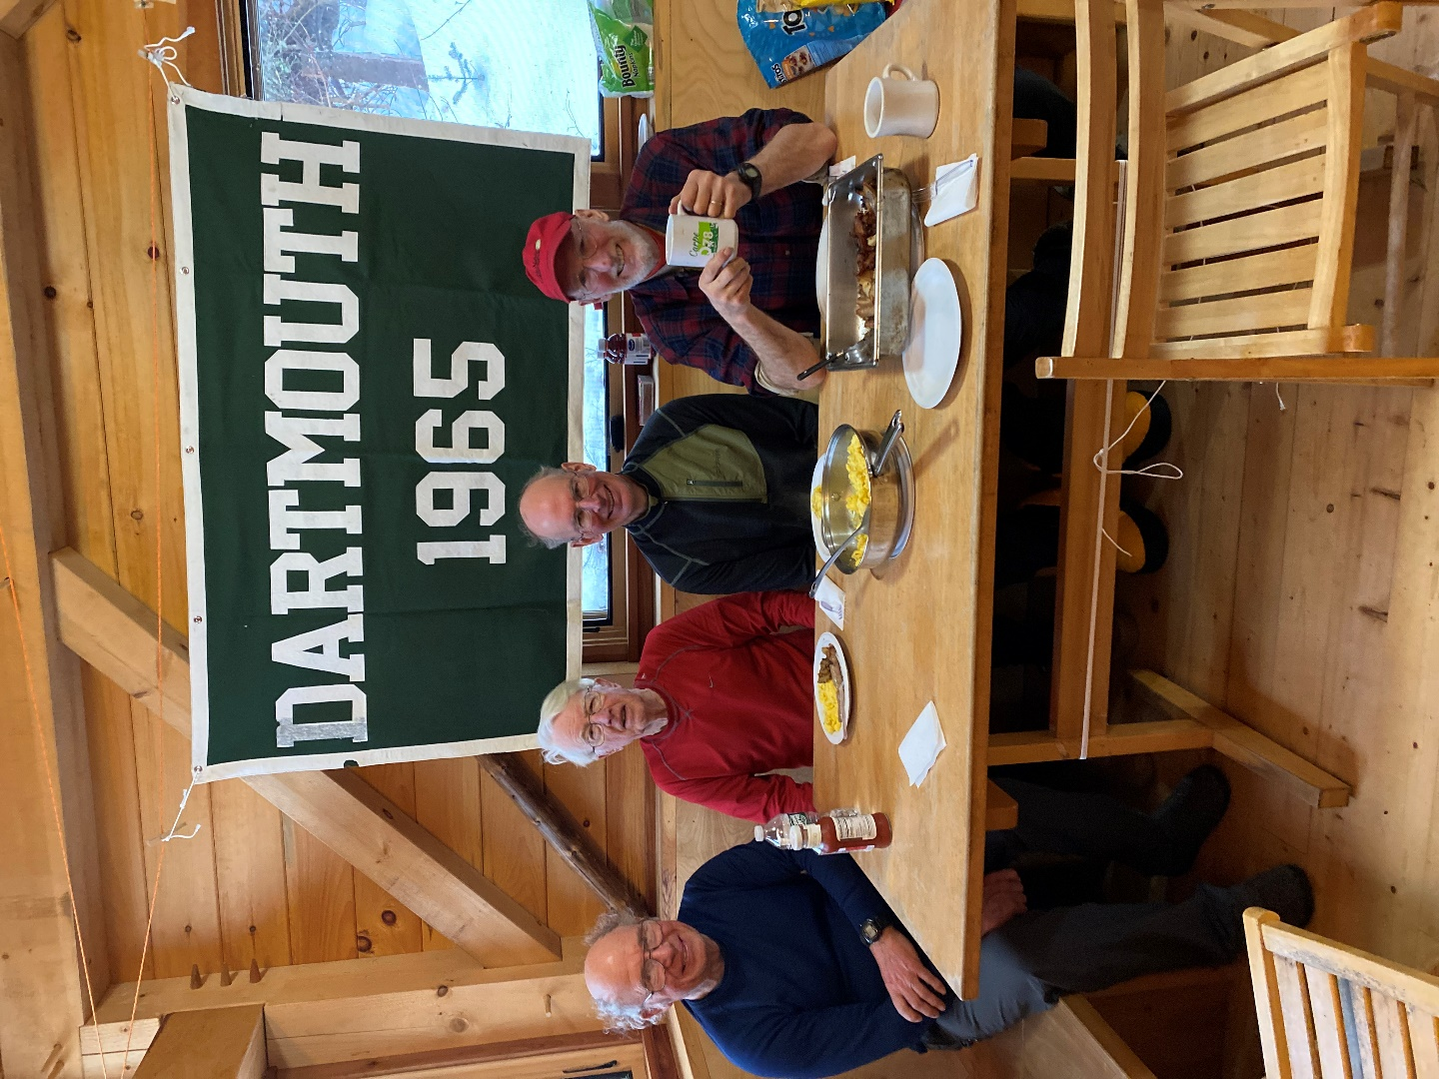

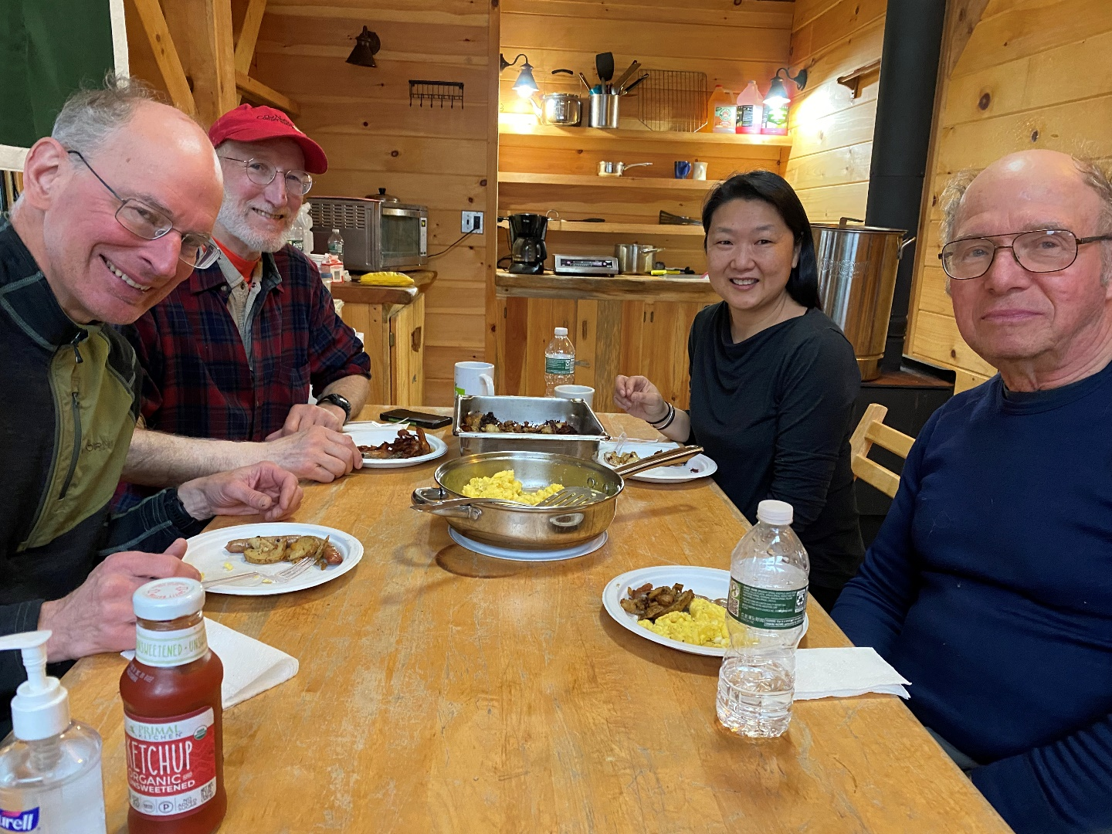

Breakfast, by Chef Bill

The meals were delicious. Beef stew from Barb Callaway (Alan had planned to join us, but was injured just before the trip), spaghetti from Sarah Young and brownies from Betsy G. Highlight were Sue Beattie’s cookies, especially her “KITCHEN SINK” cookies (see photo below).

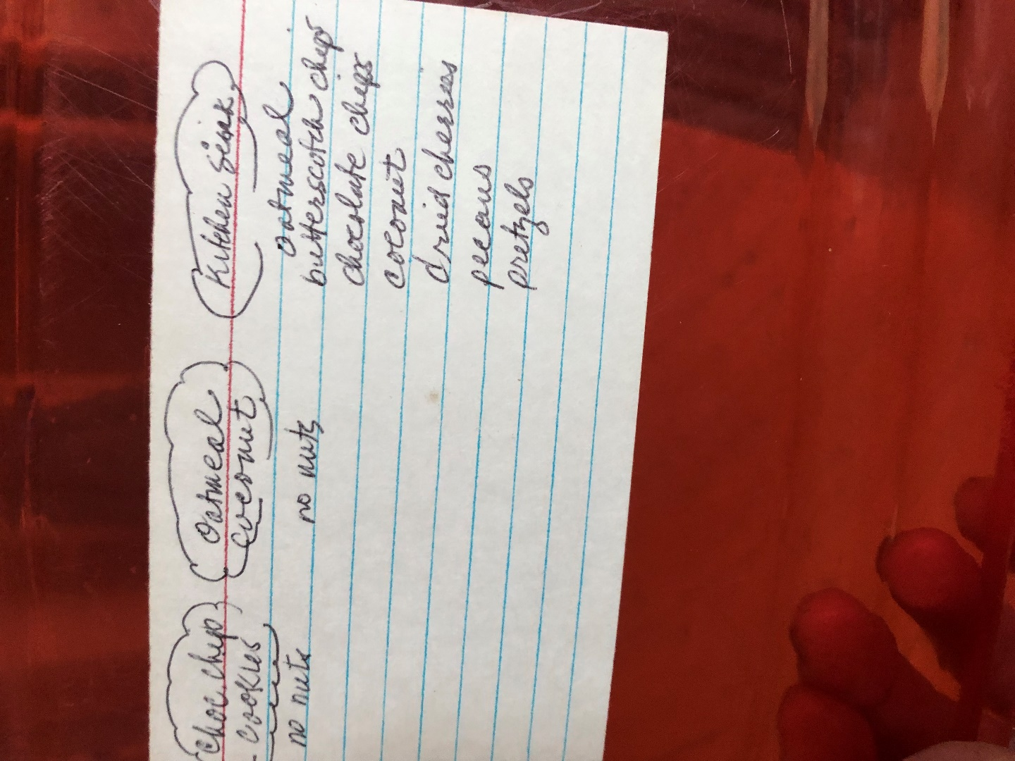

Wednesday, 2/12/2020. Temperature in the cabin kitchen area was 70+.

It warmed up Tuesday afternoon and rained Tuesday night. On Wednesday the access road was a combination of bare spots, snow and ice. We pulled our sleds back down the access road to our parked cars and drove to Appleknockers before the final trip home.

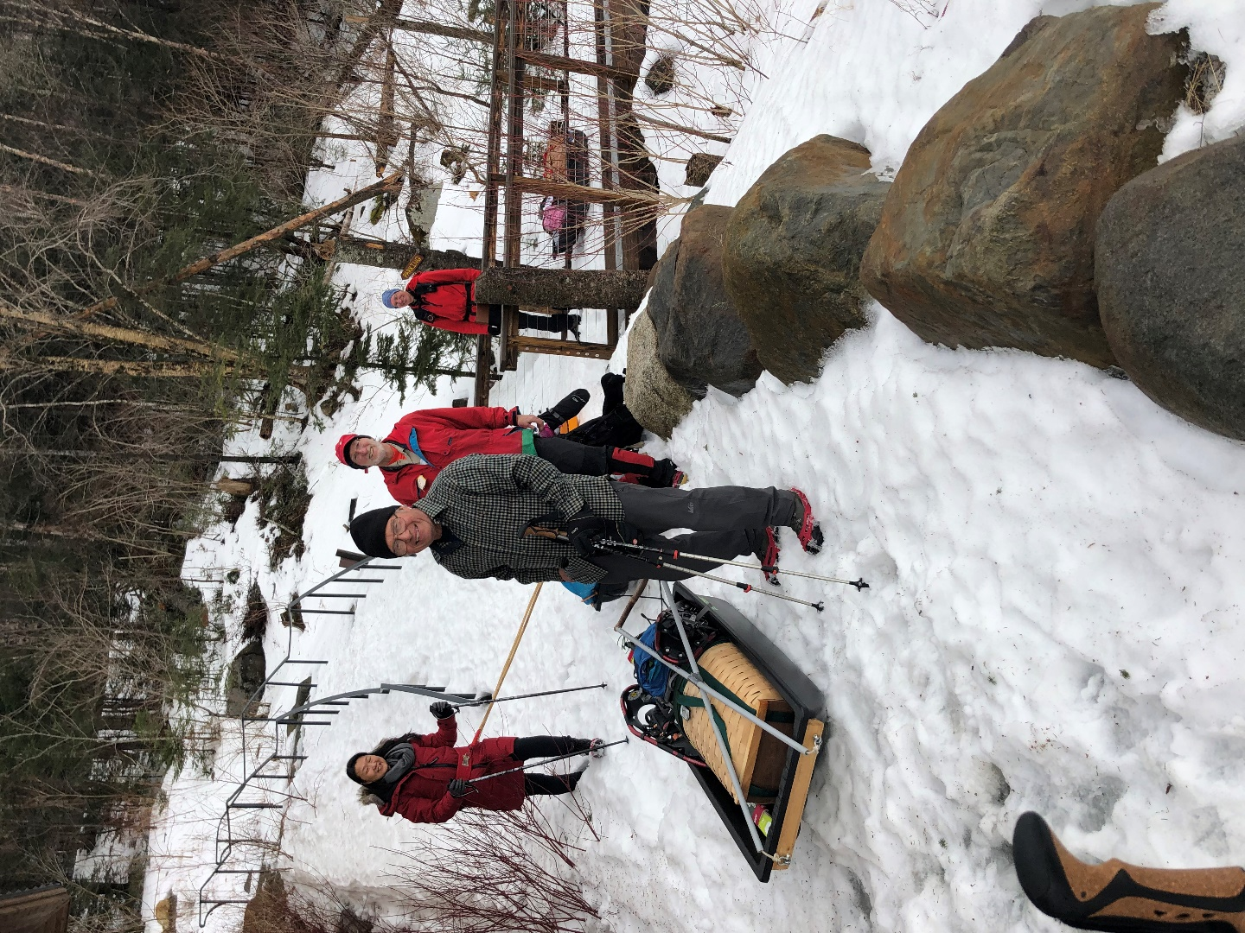

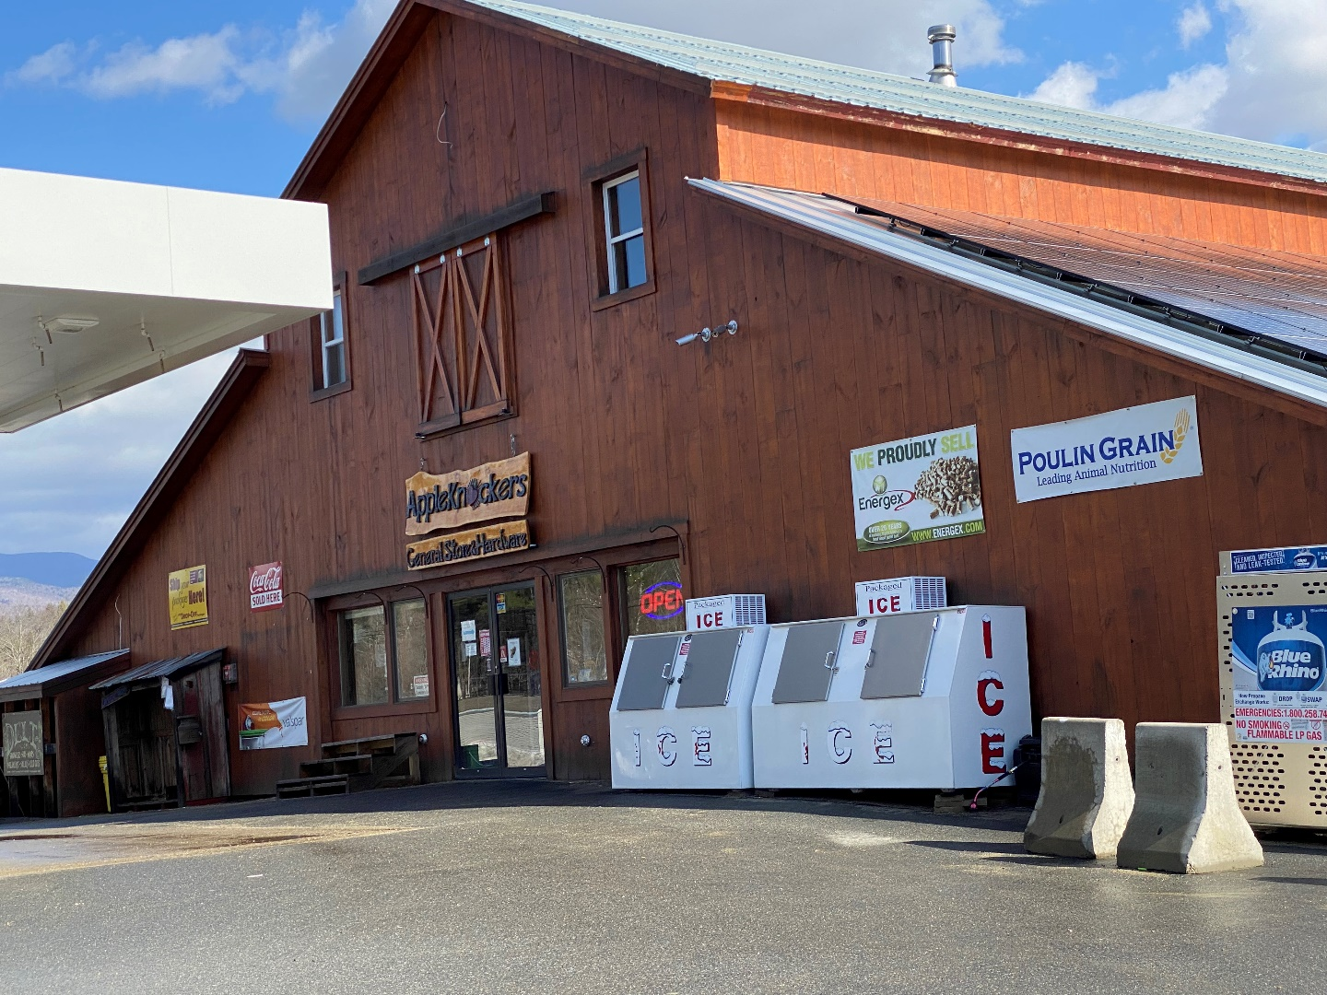

SAVE THE DATES FOR NEXT YEAR – FEBRUARY 13 – 15.

